**Energy based Location Prediction**

* **Group Members**

Gayatri Sivaraman

Jayant Bedwal

Shailesh Kelkar

Srihari Venugopalan

* **Accomplishments :**

1. Data collection is still in process using the Microsoft Band. Currently we have data from 6 participants. The locations chosen for current study are :
2. Grocery store
3. Gymnasium
4. Park (walking)
5. Library

The locations that we are planning to conduct the study in the upcoming days with more participants are:

1. Classroom
2. Home
3. Restaurant

Data which is being collected:

1. Accelerometer(Phone) , Accelerometer (Microsoft Band)
2. Gyroscope
3. Skin Temperature
4. Heart Rate
5. Speed
6. Pre-Processing of Data:

The data collected was pre-processed by applying a variety of filters before choosing the apt one. We tried the following filters: FIR filter(Rectangular), Filt Filter, Median Filter, L Filter as shown in the figure. We decided to use FIR Filter for Gyroscope data and Median Filter for Accelerometer values. This decision was made after analysing the accuracy of the Random forest classifier. The accuracy was 91% when median filter was used for both accelerometer and gyroscope data and 95% when we use median filter for accelerometer and FIR for gyroscope data. L filter and Filt filter performance wasn’t as good as the other filters as required by our application.

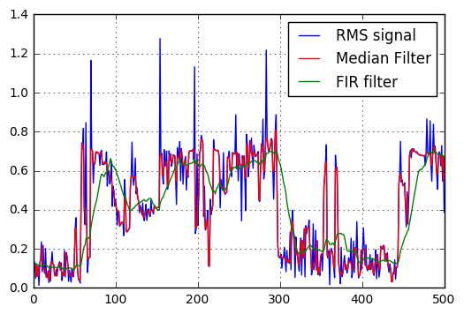 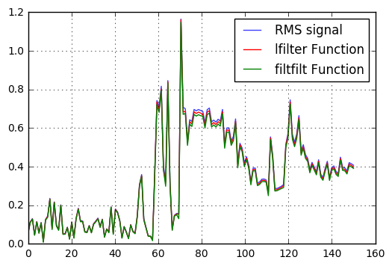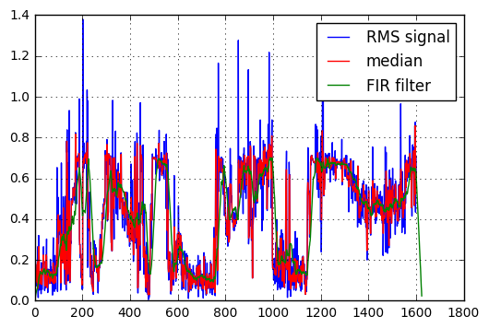

1. Frame extraction and Feature Selection:

Frame size =50 with 50% overlap (through trial and error)

We extracted the following features from our dataset

1. Mean (accelerometer, gyroscope, heart rate, skin temperature, speed)
2. Variance (accelerometer, gyroscope)
3. RMS (accelerometer, gyroscope)
4. Mean and variance of RMS ( accelerometer only)
5. Model Training

We experimented with the following classifiers:

1. SVM with rbf kernel.
2. K-NN with K=3
3. Random Forest with n_estimators=10

We performed 10 fold cross validation for the above classifiers and obtained the following results:

|  |  |
| --- | --- |
| Classifier | Accuracy |
| SVM with rbf kernel | 57% |
| K- NN (K=3) | 71% |
| Random Forest | 95% |

* **Challenges :**

1. Initially, we used mobile phone for collecting inertial sensor data. We created an android application in order to extract accelerometer and gyroscope data from a smartphone. 8 participants volunteered for our study. On analysis of the data collection process and the outcomes, we observed that the phone data is not the true representative of energy pattern for a particular place. This was even supported by a research paper [2].  
   The participants had their mobile phone either in a bag or pocket during the entire duration of the activity under consideration for example, in gym, the participants kept the mobile phone at a distant place like their locker. Hence, we acquired a Microsoft band for our study and carried out the experiments again. The results (as shown in the plots) were in favour of our analysis, and we decided to go ahead with using the Microsoft Band for our further data collection process.

Figure of comparison between Mobile Phone and Microsoft Band Data:

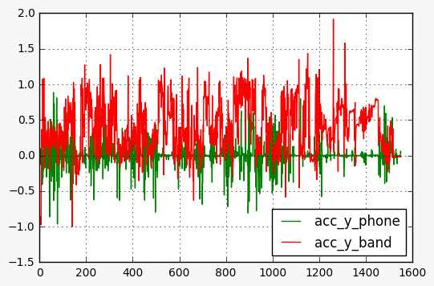

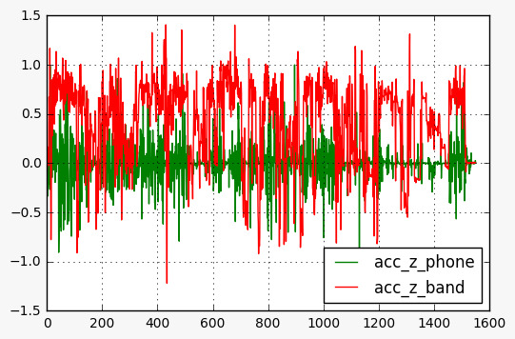

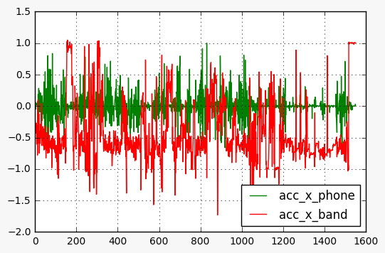

1. Since we had only one Microsoft Band available for usage, the data collection process slowed down considerably. We could only collect one data per person at a time.
2. We faced issues with setting up the infrastructure for Sensus application. The amazon web services data could not be directly downloaded, with a requirement of command line interface which was a time consuming procedure to figure out.

* **Updated Timeline**

Milestone 1 :

Data collection is going on using Microsoft Band and Sensus application.

Milestone 2 :

Completed Data pre-processing (filtering), Feature Selection, Frame extraction and training using some classifiers. We will be trying out more features to obtain better accuracy.

Milestone 3 (November end):

Model training and validation, evaluation on different classifiers for comparison, performance optimization using different configuration parameters.

* **Updated Deliverables**

We have reduced the number of locations which will be detected due to reduction in the number of hardware resources available for data collection.

* **References**

1. *Sensus: A Cross-Platform, General-Purpose System for Mobile Crowd-sensing in Human-Subject Studies* Haoyi Xiong, Yu Huang, Laura E. Barnes, and Matthew S. Gerber
2. Dey, Anind K., Katarzyna Wac, Denzil Ferreira, Kevin Tassini, Jin-Hyuk Hong, and Julian Ramos. *"Getting Closer."* Proceedings of the 13th International Conference on Ubiquitous Computing - UbiComp '11 (2011): n. pag. Web.
3. *Accelerometer Data Preparation for Activity Recognition* Hristijan Gjoreski, Matjaž Gams
4. Zhang, Mi, and Alexander Sawchuk. "*A Feature Selection-Based Framework for Human Activity Recognition Using Wearable Multimodal Sensors*." Proceedings of the 6th International ICST Conference on Body Area Networks (2011): n. pag. Web.
5. Machine Learning Tutorial - <https://github.com/justmarkham/scikit-learn-videos>